

Time: 55 minutes

Marks: / 52 marks

11 Essentials Unit 2 Test
2020

Calculator Assumed
Allowed: 1-page double sided notes, ruler

Name:

MULTIPLE CHOICE [7 marks]

1 The ratio of shaded parts to unshaded parts in the picture below is:

A 7 : 8 B 7 : 15

C 8 : 7 D 8 : 15

E 15 : 7

2 The ratio of total parts to shaded parts in the picture above is:

A 7 : 8 B 7 : 15 C 8 : 7

D 8 : 15 E 15 : 7

3 Which of the following is not equivalent to 8 : 12?

A 2 : 3 B 6 : 8 C 4 : 6

D 10 : 15 E 16 : 24

4 Holly was 108 cm tall when she turned 5 years old, and 162 cm when she turned
14 years old. Her average rate of growth is:

A 5 cm/year B 6 cm/year C 7 cm/year

D 8 cm/year E 9 cm/year

5 Maria can touch type 150 words in 3 minutes. How many words can she type in 7 minutes?

A 200 words B 250 words C 300 words

D 350 words E 400 words

6 Half an hour, converted to seconds, is:

A 36 seconds B 180 seconds C 360 seconds

D 1800 seconds E 3600 seconds

7 Written in 24-hour time, 5:45 pm is:

A 1345 B 1745 C 0545

D 1545 E 1945

SHORT ANSWER [45 marks]

Question 1 [2, 1 = 3 marks]
The ratio of boys to girls in Year 11 is 5 : 6. There are 72 girls in Year 11.

- How many boys are there in Year 11?

- What is the total number of students in the year level?

Question 2 [5 marks]

This graph shows the stopping distances for cars on different surfaces.
a) Estimate the stopping distances for cars travelling in the following conditions.

i) snow at 80 km/h

ii) gravel at 50 km/h

b) Which road conditions have roughly the same stopping distances?

c) Approximately how much further does it take to stop on ice than a dry road when you are travelling at 80 km/h?

d) Approximately how much further does it take to stop from 110 km/h than at 60 km/h on a wet road?

Question 3 [1, 1 = 2 marks]

When there was a cyclone in Queensland, the price of bananas went up. They cost $47.25 for 9 kilograms.

- What is the price per kilogram?

- How much would it cost to buy 4 kilograms?

Question 4 [3,2 = 5 marks]
Milly entered the shotput at an athletics carnival. Her 14 distances are shown below (in cm):

415 412 407 413 421 405 419 420 409 405 420 404 417

Arabella has also entered the shotput. She recorded the following distances (in cm):

406 414 409 413 419 414 403 423 412 409 415 426 419

- Draw a back-to-back stem-and-leaf plot for their distances.

- Who is better at shotput? Explain why.

Question 5 [2 marks]

Jack and Ben are arguing who is the faster at riding their bikes. Jack says he can ride at 26km/h while Ben says he can ride at 7.5m/s. Who is faster on their bike? Show your working out.

Question 6 [2, 1 = 3 marks]
The scale is 1: 1000. Calculate the real life-lengths of each feature on the map:
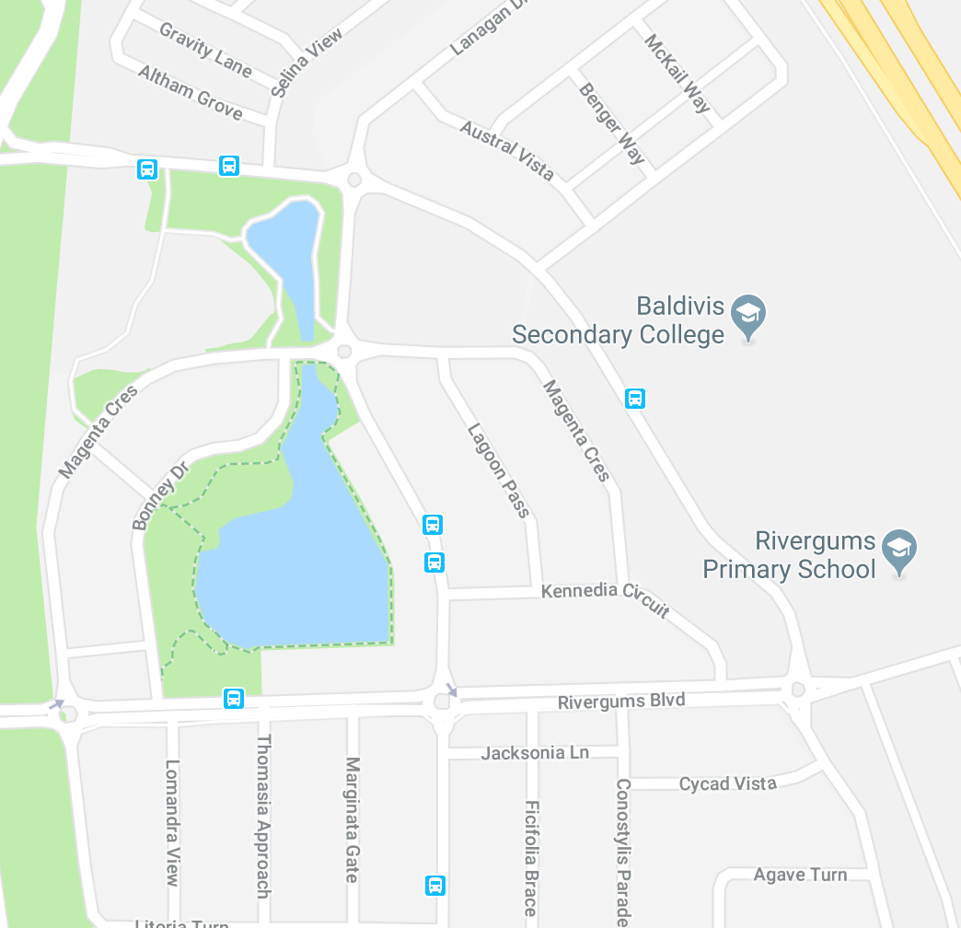

- The width of the lake (the black dots)

- If Tommy walks at a speed of 5m per minute, how long does it take him to walk to school?

Question 7 [2,2,2 =6 marks]

Answer the following percentage questions, showing all working:

- What percentage of $48 is $3?

- At the start of 2015, you earned $350 per week in your job. If you first got a 4% pay rise and later got a 3% pay rise, how much do you now earn each week?

- A plumber’s quote is $350 before GST. What is the total amount you will have to pay, including the 10% GST?

Question 8 [2,2,2,2 = 8 marks]
The table below shows the tide heights at a beach for the first two weeks of September.

- At what times did the high tides occur on the 4th?

- What day and time did the high tide of the greatest height occur?

- What is the time difference between the high and low tides on the morning of the 6th?

- To go to a secret fishing spot Jack needs to complete a river crossing. To cross the river safely, Jack requires the low tide to be 0.3m or lower. If he doesn’t want to be stranded overnight, what dates can he go fishing in his secret spot?

Question 9 [5 marks]
Jade travels from her home to Fremantle to go to work. The graph shows the distance Jade was from Fremantle as she travelled to work on Friday. Jade left home at 9:00 am to drive to Fremantle. She stopped at a café for a quick breakfast with her friend Aden. After breakfast, Jade dropped Aden back at his house before she continued her journey to work.

- What was Jade’s average speed on the way to the café in km/h?

- How long did Jade and Aden take to have breakfast?

- At what time did they leave the café?

- How far does Aden live from the café?

- After dropping off Aden, what was Jade’s average speed on the way to Fremantle in km/h?

Question 10 [6 marks]

Daniel has moved out of home to live in a unit. He needs to be at work by 8:30am and has to catch a bus to a station and then a train. His walk from home to the bus stop takes 2 minutes. The bus trip takes 15 minutes and buses leave every 15 minutes from 6:00 am. The train trip takes 10 minutes and trains leave every 20 minutes from 6:05am. Daniel’s workplace is a 5-minute walk from the station. What is the latest time Daniel can leave home and still get to work on time? Show your working out.

